Mình phải tạo ra sản phẩm cá nhân cho môn phát triển hệ thống thương mại điện tử là dùng laravel ( bắt buộc có gợi ý sản phẩm và thanh toán và chủ đề là bán dụng cụ bóng đá), và môn phát triển phần mềm hướng dịch vụ có thể dùng laravel nên mình tính làm 2 môn này là 1 project nhưng theo mô hình môn phát triền phần mềm hướng dịch vụ và đây là mô hình mình đang được học trên lớp 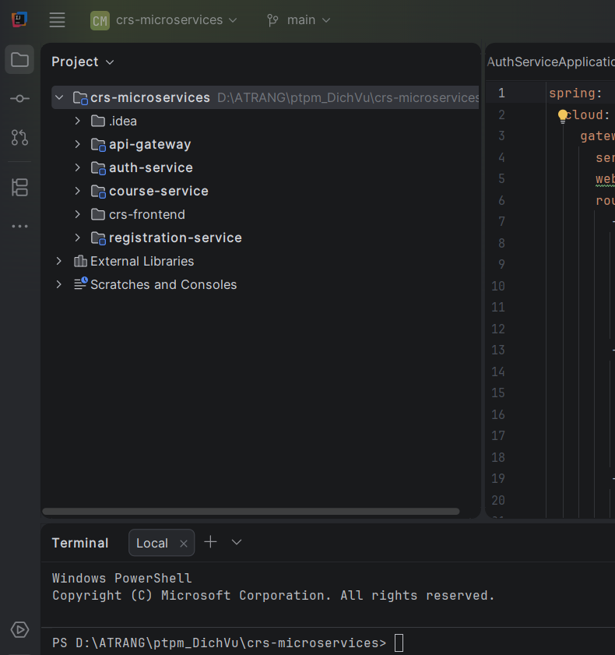

- Mình dùng mysql cho cơ sở dữ liệu và mình đã thiết kế được 1 chút database rồi
- auth-service (Database: auth_db)
// 1.1 database/migrations/2026_08_12_125836_create_users_table.php
use Illuminate\Database\Migrations\Migration;
use Illuminate\Database\Schema\Blueprint;
use Illuminate\Support\Facades\Schema;

return new class extends Migration {
public function up(): void {
Schema::create('users', function (Blueprint $table) {
$table->id();
$table->string('name');
$table->string('email')->unique();
$table->timestamp('email_verified_at')->nullable();
$table->string('password');
$table->string('phone', 15)->nullable();
$table->string('role', 20)->default('customer')->index();
$table->boolean('is_active')->default(true);
$table->rememberToken();
$table->timestamps();
});
}

public function down(): void {
Schema::dropIfExists('users');
}
};

// 1.2 database/migrations/2026_08_12_130001_create_addresses_table.php
return new class extends Migration {
public function up(): void {
Schema::create('addresses', function (Blueprint $table) {
$table->id();
$table->foreignId('user_id')->constrained('users')->onDelete('cascade');
$table->string('recipient_name');
$table->string('phone', 15);
$table->string('province');
$table->string('district');
$table->string('ward');
$table->string('street_address');
$table->boolean('is_default')->default(false);
$table->timestamps();
});
}

public function down(): void {
Schema::dropIfExists('addresses');
}
};

// 1.3 database/migrations/2026_08_16_025020_create_sessions_table.php
return new class extends Migration {
public function up(): void {
Schema::create('sessions', function (Blueprint $table) {
$table->string('id')->primary();
$table->unsignedBigInteger('user_id')->nullable()->index();
$table->string('ip_address', 45)->nullable();
$table->text('user_agent')->nullable();
$table->longText('payload');
$table->integer('last_activity')->index();
});
}

public function down(): void {
Schema::dropIfExists('sessions');
}
};

- catalog-service (Database: catalog_db)
// 2.1 database/migrations/2026_08_12_130028_create_categories_table.php
use Illuminate\Database\Migrations\Migration;
use Illuminate\Database\Schema\Blueprint;
use Illuminate\Support\Facades\Schema;

return new class extends Migration {
public function up(): void {
Schema::create('categories', function (Blueprint $table) {
$table->id();
$table->foreignId('parent_id')->nullable()->constrained('categories')->onDelete('set null');
$table->string('name');
$table->string('slug')->unique();
$table->boolean('is_active')->default(true);
$table->timestamps();
});
}

public function down(): void {
Schema::dropIfExists('categories');
}
};

// 2.2 database/migrations/2026_08_12_130112_create_brands_table.php
return new class extends Migration {
public function up(): void {
Schema::create('brands', function (Blueprint $table) {
$table->id();
$table->string('name');
$table->string('slug')->unique();
$table->string('logo_path')->nullable();
$table->boolean('is_active')->default(true);
$table->timestamps();
});
}

public function down(): void {
Schema::dropIfExists('brands');
}
};

// 2.3 database/migrations/2026_08_12_130127_create_products_table.php
return new class extends Migration {
public function up(): void {
Schema::create('products', function (Blueprint $table) {
$table->id();
$table->foreignId('category_id')->constrained('categories')->onDelete('restrict');
$table->foreignId('brand_id')->constrained('brands')->onDelete('restrict');
$table->string('name');
$table->string('slug')->unique();
$table->text('description')->nullable();
$table->boolean('is_active')->default(true);
$table->softDeletes();
$table->timestamps();

$table->index(['category_id', 'is_active']);
$table->index(['brand_id', 'is_active']);
});
}

public function down(): void {
Schema::dropIfExists('products');
}
};

// 2.4 database/migrations/2026_08_12_130147_create_product_variants_table.php
return new class extends Migration {
public function up(): void {
Schema::create('product_variants', function (Blueprint $table) {
$table->id();
$table->foreignId('product_id')->constrained('products')->onDelete('cascade');
$table->string('sku', 100)->unique();
$table->decimal('price', 12, 2);
$table->decimal('sale_price', 12, 2)->nullable();
$table->unsignedInteger('stock')->default(0);
$table->json('attributes');
$table->boolean('is_active')->default(true);
$table->timestamps();
});
}

public function down(): void {
Schema::dropIfExists('product_variants');
}
};

// 2.5 database/migrations/2026_08_12_130207_create_product_images_table.php
return new class extends Migration {
public function up(): void {
Schema::create('product_images', function (Blueprint $table) {
$table->id();
$table->foreignId('product_id')->constrained('products')->onDelete('cascade');
$table->string('image_path');
$table->boolean('is_primary')->default(false);
$table->unsignedInteger('sort_order')->default(0);
$table->timestamps();
});
}

public function down(): void {
Schema::dropIfExists('product_images');
}
};

- order-service (Database: order_db)
// 3.1 database/migrations/2026_08_12_130289_create_coupons_table.php
use Illuminate\Database\Migrations\Migration;
use Illuminate\Database\Schema\Blueprint;
use Illuminate\Support\Facades\Schema;

return new class extends Migration {
public function up(): void {
Schema::create('coupons', function (Blueprint $table) {
$table->id();
$table->string('code', 50)->unique();
$table->string('type', 20);
$table->decimal('value', 12, 2);
$table->decimal('min_order_amount', 12, 2)->default(0.00);
$table->decimal('max_discount_amount', 12, 2)->nullable();
$table->integer('usage_limit')->nullable();
$table->integer('used_count')->default(0);
$table->integer('limit_per_user')->default(1);
$table->boolean('is_active')->default(true)->index();
$table->timestamp('starts_at')->nullable();
$table->timestamp('expires_at')->nullable();
$table->timestamps();

$table->index(['starts_at', 'expires_at']);
});
}

public function down(): void {
Schema::dropIfExists('coupons');
}
};

// 3.2 database/migrations/2026_08_12_130231_create_carts_and_cart_items_table.php
return new class extends Migration {
public function up(): void {
Schema::create('carts', function (Blueprint $table) {
$table->id();
$table->unsignedBigInteger('user_id')->unique(); // Tham chiếu Auth Service
$table->timestamps();
});

Schema::create('cart_items', function (Blueprint $table) {
$table->id();
$table->foreignId('cart_id')->constrained('carts')->onDelete('cascade');
$table->unsignedBigInteger('product_id')->index(); // Tham chiếu Catalog Service
$table->unsignedBigInteger('variant_id')->index(); // Tham chiếu Catalog Service
$table->unsignedInteger('quantity')->default(1);
$table->timestamps();

$table->unique(['cart_id', 'variant_id']);
});
}

public function down(): void {
Schema::dropIfExists('cart_items');
Schema::dropIfExists('carts');
}
};

// 3.3 database/migrations/2026_08_12_130298_create_orders_and_order_items_table.php
return new class extends Migration {
public function up(): void {
Schema::create('orders', function (Blueprint $table) {
$table->id();
$table->string('order_code', 50)->unique();
$table->unsignedBigInteger('user_id'); // Tham chiếu Auth Service
$table->foreignId('coupon_id')->nullable()->constrained('coupons')->onDelete('set null');
$table->string('shipping_name');
$table->string('shipping_phone', 15);
$table->text('shipping_address');
$table->decimal('subtotal', 12, 2);
$table->decimal('shipping_fee', 12, 2)->default(0.00);
$table->decimal('discount_amount', 12, 2)->default(0.00);
$table->decimal('total_amount', 12, 2);
$table->string('order_status', 30)->default('pending');
$table->string('payment_status', 30)->default('unpaid');
$table->text('note')->nullable();
$table->timestamps();

$table->index(['user_id', 'order_status', 'payment_status']);
});

Schema::create('order_items', function (Blueprint $table) {
$table->id();
$table->foreignId('order_id')->constrained('orders')->onDelete('cascade');
$table->unsignedBigInteger('product_id')->index(); // Tham chiếu Catalog Service
$table->unsignedBigInteger('variant_id')->index(); // Tham chiếu Catalog Service
$table->string('product_name');
$table->json('variant_attributes');
$table->string('sku', 100);
$table->decimal('unit_price', 12, 2);
$table->unsignedInteger('quantity');
$table->decimal('subtotal', 12, 2);
$table->timestamps();
});
}

public function down(): void {
Schema::dropIfExists('order_items');
Schema::dropIfExists('orders');
}
};

// 3.4 database/migrations/2026_08_12_130301_create_coupon_usages_table.php
return new class extends Migration {
public function up(): void {
Schema::create('coupon_usages', function (Blueprint $table) {
$table->id();
$table->foreignId('coupon_id')->constrained('coupons')->onDelete('cascade');
$table->unsignedBigInteger('user_id'); // Tham chiếu Auth Service
$table->foreignId('order_id')->constrained('orders')->onDelete('cascade');
$table->decimal('discount_amount', 12, 2);
$table->timestamps();

$table->unique(['coupon_id', 'order_id']);
$table->index(['coupon_id', 'user_id']);
});
}

public function down(): void {
Schema::dropIfExists('coupon_usages');
}
};

- payment-service (Database: payment_db)
// 4.1 database/migrations/2026_08_12_130320_create_payments_and_transactions_table.php
use Illuminate\Database\Migrations\Migration;
use Illuminate\Database\Schema\Blueprint;
use Illuminate\Support\Facades\Schema;

return new class extends Migration {
public function up(): void {
Schema::create('payments', function (Blueprint $table) {
$table->id();
$table->unsignedBigInteger('order_id')->unique(); // Tham chiếu Order Service
$table->string('payment_method', 30);
$table->decimal('amount', 12, 2);
$table->string('status', 30)->default('pending')->index();
$table->timestamp('paid_at')->nullable();
$table->timestamps();
});

Schema::create('payment_transactions', function (Blueprint $table) {
$table->id();
$table->foreignId('payment_id')->constrained('payments')->onDelete('cascade');
$table->string('gateway', 30);
$table->string('transaction_code', 100)->nullable()->index();
$table->string('response_code', 20)->nullable();
$table->decimal('amount', 12, 2);
$table->string('status', 30);
$table->json('raw_payload')->nullable();
$table->timestamps();
});
}

public function down(): void {
Schema::dropIfExists('payment_transactions');
Schema::dropIfExists('payments');
}
};

- recommendation-service (Database: recommendation_db)
// 5.1 database/migrations/2026_08_12_130340_create_user_product_interactions_table.php
use Illuminate\Database\Migrations\Migration;
use Illuminate\Database\Schema\Blueprint;
use Illuminate\Support\Facades\Schema;

return new class extends Migration {
public function up(): void {
Schema::create('user_product_interactions', function (Blueprint $table) {
$table->id();
$table->unsignedBigInteger('user_id'); // Tham chiếu Auth Service
$table->unsignedBigInteger('product_id'); // Tham chiếu Catalog Service
$table->string('interaction_type', 30);
$table->unsignedTinyInteger('weight');
$table->timestamps();

$table->index(['user_id', 'product_id', 'interaction_type'], 'upi_user_product_type_idx');
});
}

public function down(): void {
Schema::dropIfExists('user_product_interactions');
}
};

// 5.2 database/migrations/2026_08_12_130408_create_reviews_table.php
return new class extends Migration {
public function up(): void {
Schema::create('reviews', function (Blueprint $table) {
$table->id();
$table->unsignedBigInteger('user_id')->index(); // Tham chiếu Auth Service
$table->unsignedBigInteger('product_id')->index(); // Tham chiếu Catalog Service
$table->unsignedBigInteger('order_item_id')->unique(); // Tham chiếu Order Service
$table->unsignedTinyInteger('rating');
$table->text('comment')->nullable();
$table->boolean('is_visible')->default(true);
$table->timestamps();
});
}

public function down(): void {
Schema::dropIfExists('reviews');
}
};

- Project này là làm cá nhân và làm trong khoảng 1 tháng rưỡi.
- Và giờ mình tính dùng con AI cursor agent này để support giúp mình làm giao diện đẹp và hỗ trợ mình phần BE. Nhưng mình vẫn chưa gen bất kỳ câu lệnh nào cho AI này.
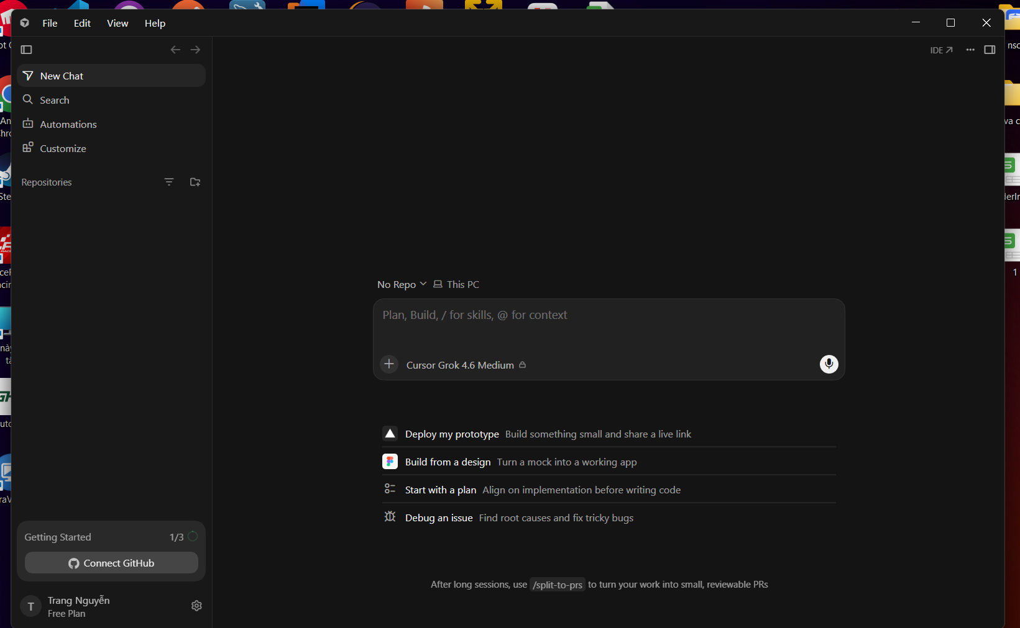
Mình cũng có định hướng lấy project này để sau mở rộng làm đồ án tốt nghiệp luôn.

